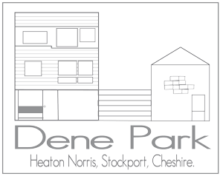

**Dene Park Estate Request/Complaint Form**

This form is for the use of Dene Park Estate residents and non-residents. It can be used to submit a request, complaint or idea to the directors of Dene Park Maintenance Ltd. (DPM) or court representatives on the DPM Committee.

* Non-urgent submissions will receive a response after the next meeting has taken place. (DPM board meetings usually occur monthly.) Urgent submissions will receive a response as soon as possible.
* Please note, if your request is regarding trees on the estate, please consult our Tree Policy (<https://www.denepark.org/documents/tree-policy/> ).
* It is the directors’ duty to uphold the DPM covenant (<https://www.denepark.org/covenant/> ) to ensure that the appearance of the estate remains unaltered from its award winning design form. Requests that are not in line with the covenant are unlikely to be upheld.
* If you have a complaint about a neighbour, the directors have limited powers and they recommend that you seek a neighbourly resolution in the first instance. However, if your complaint relates to antisocial behaviour, it is also recommended that you seek a resolution direct in the first instance but, should this not resolve the matter, you should report it here: <https://www.stockport.gov.uk/anti-social-behaviour>
* Please print this form and hand it to a court representative or director or email it to [deneparkmaintenancecommittee@gmail.com](mailto:deneparkmaintenancecommittee@gmail.com) If you wish to submit this form anonymously, please do so via your court representative.

|  |
| --- |
| Your name: |
| Date of submission: |
| Your preferred contact details: |
| This is a complaint/request/idea (delete as appropriate): |
| Who else does this affect? Who else should be consulted? |
| Please add details here: |

As above, Directors usually meet monthly and will, of course, consider all matters raised as quickly as possible. Dene Park Maintenance Committee is committed to ensuring confidentiality as far as is practicable in respect of all issues raised and residents involved. However, it is also recognised that multiple residents may be affected and Directors will gladly undertake wider consultation where appropriate. Directors welcome suggestions relating to the upkeep and attractiveness of the estate.

Where a complaint is made, Directors will act with sensitivity and recognise the importance of ensuring good relations across all parties.

Residents are asked to note that Directors’ decisions must align with legislation, its Articles of Association and the Covenant.